**Business Requirement of Football Player Ability Analysis System**

Qiong Wu

Project 1

**BUSINESS REQUIREMENTS: (NOUNS AND VERBS)**

## **1. Project Overview**

The **Football Player Ability Analysis System** is designed to:

* Assist football scouts, managers, and agents in evaluating player attributes.
* Identify ideal candidates for specific tactical needs.
* Generate ability comparison reports to enhance decision-making.
* Streamline the talent identification process through structured data analysis.

## **2. Business Objectives**

The system aims to:

* **Improve scouting efficiency** by providing a structured method for collecting and analyzing player data.
* **Enhance recruitment decision-making** by enabling managers to find players that fit tactical requirements.
* **Increase player market visibility** through ability comparison reports.
* **Provide data-driven insights** using statistical models for objective player evaluations.

## **3. Key Stakeholders**

* **Football Scouts**: Import and evaluate player data.
* **Club Managers**: Find suitable players based on tactical needs.
* **Player Agents**: Showcase player strengths using comparison reports.

## **4. Functional Requirements**

### **4.1 Player Data Management**

* Scouts can import data on over **ten player attributes** across three dimensions:
  + **Technical**: Passing, dribbling, shooting, tackling, etc.
  + **Physical**: Speed, stamina, strength, agility, etc.
  + **Mental**: Vision, composure, work rate, decision-making, etc.
* The system must support:
  + **CSV/Excel file uploads**.
  + **Manual data entry**.
  + **Data validation** to ensure accuracy.
* Players will be **automatically classified** into roles:
  + **Attacker** (Strikers, Wingers).
  + **Midfielder** (Playmakers, Defensive Midfielders).
  + **Defender** (Center-backs, Full-backs).
* **Role-based weightings** will be applied for evaluation.
* The system must include an **adjustable scoring system**.

### **4.2 Player Search and Recommendations**

* Managers can **filter and search** for players based on tactical requirements:
  + Position, skill rating, age, market value, etc.
* The system will include **AI-based recommendations** to suggest the best-fit players.

### **4.3 Ability Comparison Reports**

* Agents can create **side-by-side player comparisons** with graphical insights.
* Reports must be **exportable in PDF and other shareable formats**.

### **4.4 User Roles and Access Control**

* Different permission levels will be assigned to:
  + **Scouts**: Import and evaluate player data.
  + **Managers**: Search and filter players, access AI recommendations.
  + **Agents**: Generate and export player comparison reports.
  + **Administrators**: Manage users, security, and system settings.

### **4.5 Security & Performance**

* The system must ensure:
  + **Data privacy and encryption**.
  + **Scalability** for handling large datasets.
  + **High performance** with fast search and recommendation responses.
* The UI/UX must be:
  + **Intuitive**.
  + **Easy to navigate**.
  + **Support data visualization**.

**Nouns**

* Football Player Ability Analysis System
* Scouts
* Managers
* Agents
* System Administrators
* Player Attributes
* Tactical Requirements
* Ability Comparison Reports
* Talent Identification Process
* Decision-Making
* Data Analysis
* Scouting Efficiency
* Recruitment Decision-Making
* Player Market Visibility
* Statistical Models
* Objective Player Evaluations
* Technical Attributes
* Physical Attributes
* Mental Attributes
* CSV/Excel File Uploads
* Manual Data Entry
* Data Validation
* Roles
* Scoring System
* Filtering Options
* AI-Based Recommendations
* Graphical Insights
* PDF Export
* User Roles
* Access Control
* Security Features
* Data Privacy
* Encryption
* Scalability
* Search and Recommendation Responses
* UI/UX
* Navigation
* Data Visualization

**Verbs**

* Assist
* Evaluate
* Identify
* Create
* Streamline
* Enhance
* Import
* Manage
* Automate
* Classify
* Enable
* Search
* Filter
* Find
* Provide
* Generate
* Showcase
* Maintain
* Ensure
* Improve
* Collect
* Analyze
* Support
* Apply
* Adjust
* Suggest
* Compare
* Export
* Secure
* Handle
* Maintain
* Navigate

**Classes**

* User
  + Scout
  + Manager
  + Agent
  + System Administrator
* Player
  + Attribute (Technical, Physical, Mental)
  + Role (Attacker, Midfielder, Defender)
  + Score
  + Evaluation Model
* Player Report
  + File (CSV, Excel)
  + Import / Export
  + Validation
* Comparison Report
* Search & Recommendation System
  + Filter
  + Search
  + AI-Based Recommendation
  + Tactical Requirement

**Target Audience**

* Football Scouts
  + Responsible for evaluating and importing player data (technical, physical, and mental attributes).
  + Need automated classification of players into roles.
  + Require tools for data validation and structured scouting reports.
* Club Managers & Coaches
  + Need to search, filter, and identify players based on tactical requirements.
  + Require AI-based recommendations to suggest best-fit players.
  + Want data-driven insights for recruitment decisions.
* Player Agents
  + Use ability comparison reports to showcase their clients.
  + Need exportable reports (PDF, graphical insights) for easy sharing with clubs.
  + Benefit from market visibility enhancements for their players.

**Rules**

* Player data is imported by authorized scouts. All imported data must pass validation checks (e.g., missing values, incorrect formats).
* Each player must have a unique identifier (ID) for tracking and comparison.
* Players must be classified into one of three roles: Attacker, Midfielder, or Defender. Classification must be based on predefined weightings for technical, physical, and mental attributes.
* The system allows role weightings to be adjusted by managers.
* Managers are able to filter players based on position, skill rating, age, and market value.
* AI-based recommendations suggest players based on historical performance and similarity scores.
* Players are compared using at least three attributes in a report.

**Challenge Questions**

1. How will the system handle missing or inaccurate player data?
2. What mechanisms will be in place to prevent data conflicts caused by different scouts studying the same player?
3. How will the system scale to effectively handle large datasets containing thousands of players?
4. How will role-based weights be adjusted for different playing styles and leagues?

**Summary of Classes**

* **User**
  + **Attributes**:
    - Name
    - Age
    - Role (Scout, Manager, Agent, System Administrator)
    - Experience
  + permission levels
  + role.
* **Player**
  + **Attributes**:
    - Unique ID
    - Name
    - Age
    - Market Value
    - Technical Attributes (Passing, Dribbling, Shooting, Tackling, etc.)
    - Physical Attributes (Speed, Stamina, Strength, Agility, etc.)
    - Mental Attributes (Vision, Composure, Work Rate, Decision-Making, etc.)
    - Role (Attacker, Midfielder, Defender)
    - Score (based on role-based weightings)
  + Classified into role.
  + Evaluated
* **Player Report**
  + **Attributes**:
    - File Type (CSV, Excel)
    - Imported Data
    - Validation Status (Valid, Invalid)
  + Created by scouts.
  + Validated by the system before analysis.
* **Comparison Report**
  + **Attributes**:
    - Player 1
    - Player 2
    - Comparison Metrics (e.g., Technical, Physical, Mental Attributes)
    - Graphical Insights
    - Export Format (PDF, etc.)
* **Search & Recommendation Filter**
  + **Attributes**:
    - Filter Options (Position, Skill Rating, Age, Market Value, etc.)
    - AI-Based Recommendations
    - Tactical Requirements
  + **Associations**:
    - Used by managers to find players.
    - Provides AI-based suggestions for best-fit players.
* **Evaluation Model**
  + **Attributes**:
    - Role-Based Weightings (Attacker, Midfielder, Defender)
    - Adjustable Scoring System
  + **Associations**:
    - Applied to player data for classification and scoring.
    - Adjusted by managers based on tactical needs.

**Users:**

**Persona – Football Scout**  
**Name:** James Thompson  
**Age:** 38  
**Role:** Football Scout for Newcastle United  
**Experience:** 12 years of scouting experience  
**Intent of Using the System:** Efficiently assess and track player abilities for talent identification  
**Engagement Level:** High – Regularly inputs and updates data to maintain an accurate scouting database  
**Spending Willingness:** Professional tool budget provided by the club

**Backstory:**  
James has been scouting football talent for over a decade, traveling to matches across Europe to identify promising players. He is detail-oriented and values data accuracy to support his reports. James frequently collaborates with coaching staff to recommend players who align with Newcastle United’s tactical needs.

**Scenario:**  
James is attending a youth tournament in Spain. After observing a standout midfielder, he quickly inputs the player’s technical, physical, and mental attributes into the system via his tablet. Later, he revisits the profile to refine the player’s role classification after consulting with his manager.

**User Stories:**

1. **As a football scout, I want to manually input player data so that I can complete my player assessment tasks.**

* Action: James attends matches and manually records key performance data like passing accuracy, stamina, and positioning in the system for detailed evaluation.

1. **As a football scout, I want to modify player classifications and update their abilities to demonstrate my expertise and ongoing accuracy.**

* Action: After reviewing match footage, James updates a player’s role from ‘defensive midfielder’ to ‘box-to-box midfielder’ and adjusts their stamina rating to reflect improved performance.

1. **As a football scout, I want to validate the data I upload to ensure accuracy and completeness before analyzing it.**

* Action: Before submitting his assessments, James reviews flagged inconsistencies (e.g., unrealistic speed ratings) and corrects any errors to maintain data reliability.

1. **As a football scout, I want to compare players based on specific tactical requirements so that I can recommend the best-fit candidates to the coaching staff.**

* Action: James filters his database for midfielders with high stamina, strong passing, and effective positioning to identify top prospects for the manager’s tactical strategy.

1. **As a football scout, I want to generate detailed player reports so that I can present insights effectively to coaching staff and decision-makers.**

* Action: James exports comprehensive player profiles, including radar charts and performance trends, to discuss potential signings in team meetings.

**Persona – Football Club Manager**  
**Name:** Erik ten Hag  
**Age:** 55  
**Role:** Manchester United Football Manager  
**Experience:** 10 years of experience in football management  
**Intent of Using the System:** Efficiently identify and evaluate players to strengthen the squad  
**Engagement Level:** High – Frequently uses data-driven insights to inform transfer decisions and squad strategy  
**Spending Willingness:** Backed by the club’s resources for advanced scouting and analysis tools

**Backstory:**  
Erik ten Hag is an experienced manager known for his tactical expertise and structured approach to squad building. He values data-driven insights to support his decisions and often explores new talent that fits his preferred playing style. Balancing immediate team needs with long-term strategy is crucial for his role.

**Scenario:**  
Ahead of the summer transfer window, Erik needs to find a versatile midfielder who excels in pressing and ball recovery. Using the system, he applies custom filters to narrow down candidates, explores AI-based suggestions, and requests detailed performance comparison reports to support his decisions.

**User Stories:**

1. **As a football manager, I want to filter players based on tactical requirements so that I can identify the best players for my team.**

* Action: Erik filters the system to find midfielders with high defensive work rate, strong passing accuracy, and above-average stamina to match his tactical philosophy.

1. **As a football manager, I want to receive AI-based recommendations to explore new player options efficiently.**

* Action: After applying filters, Erik reviews AI-generated suggestions that highlight emerging talents from lesser-known leagues, providing fresh options for recruitment.

1. **As a football manager, I want to generate performance comparison reports so that I can compare multiple players before making transfer decisions.**

* Action: Erik exports a detailed comparison report visualizing key attributes such as defensive duels won, passing range, and progressive carries, allowing him to assess potential signings side-by-side.

1. **As a football manager, I want to track player development trends so that I can evaluate long-term potential.**

* Action: Erik reviews trend graphs showing players' improvement in decision-making, fitness levels, and technical skills over multiple seasons to make informed investment decisions.

1. **As a football manager, I want to create customized watchlists so that I can monitor shortlisted players for future transfer windows.**

* Action: Erik compiles a watchlist of promising young talents and periodically reviews their performance updates to time his recruitment effectively.

**UML diagram**

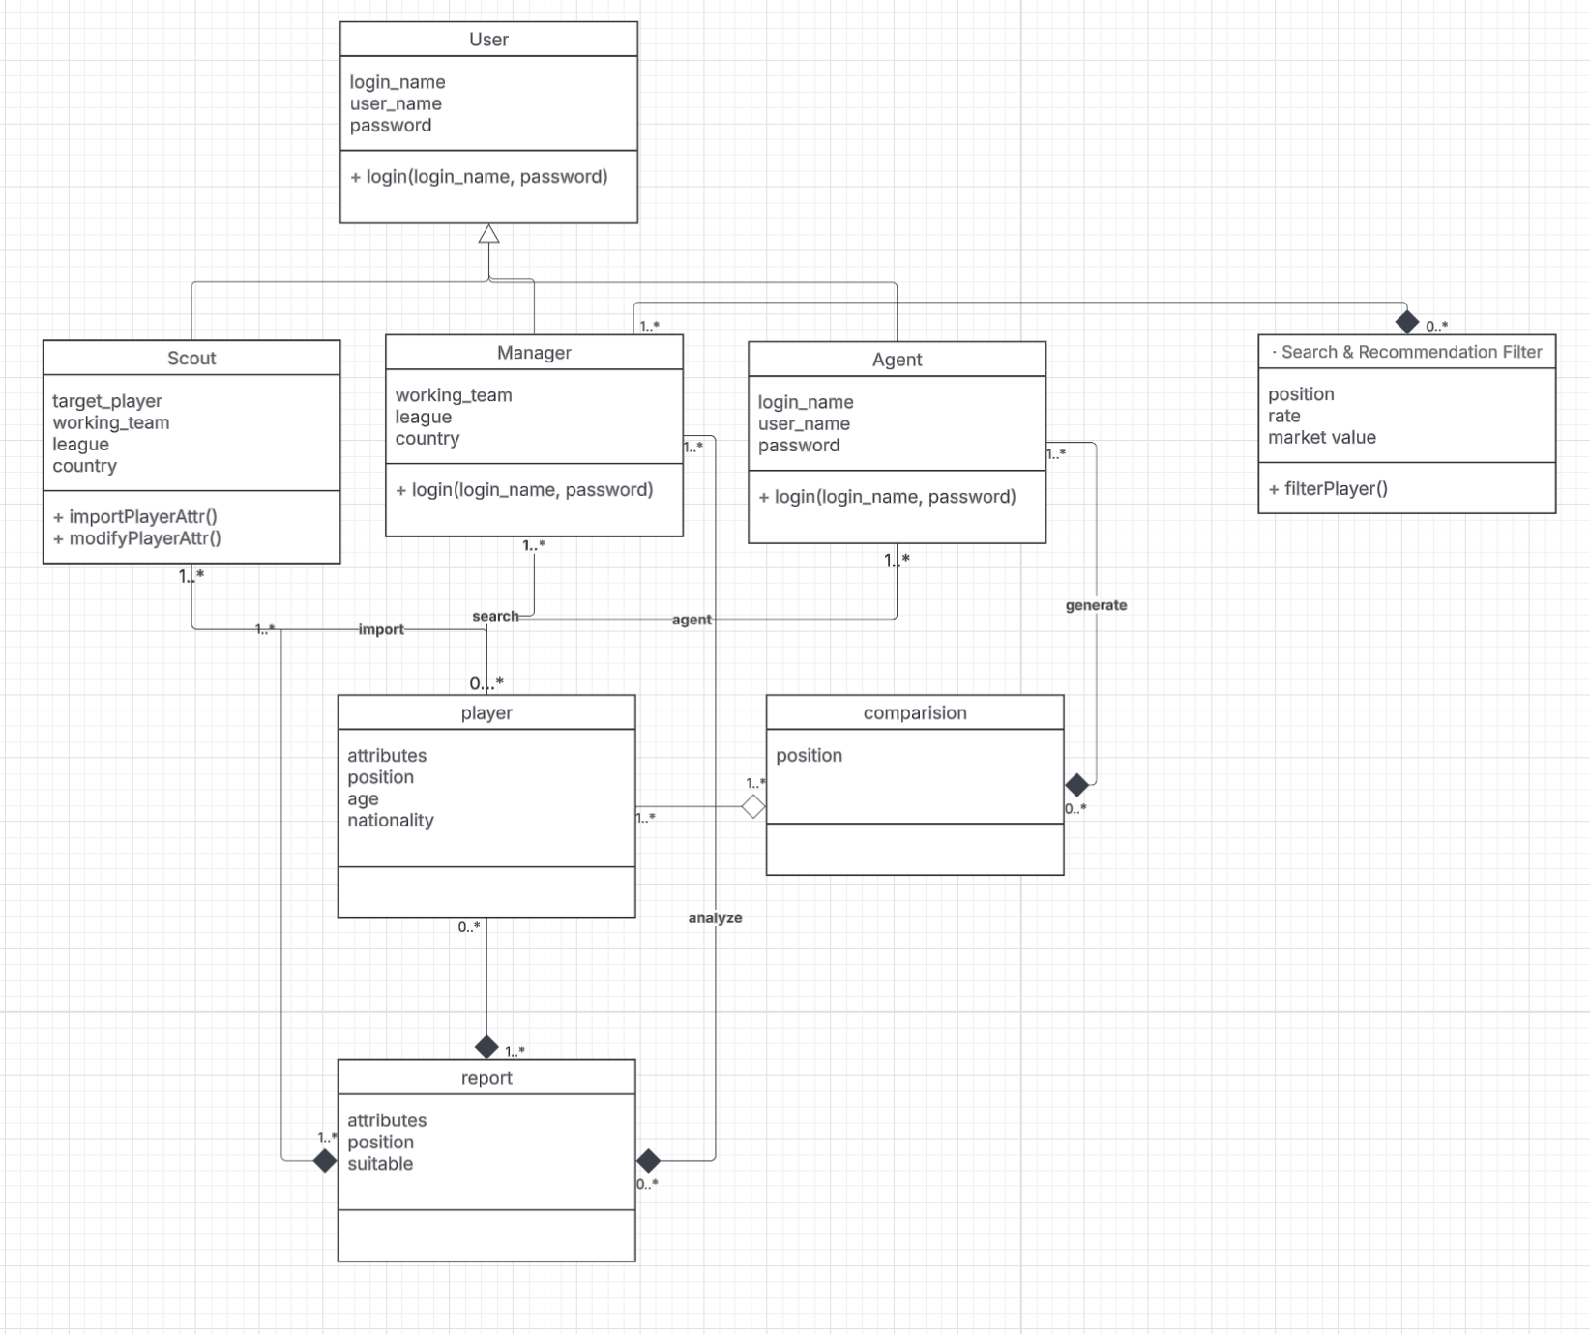

Interface

Login:

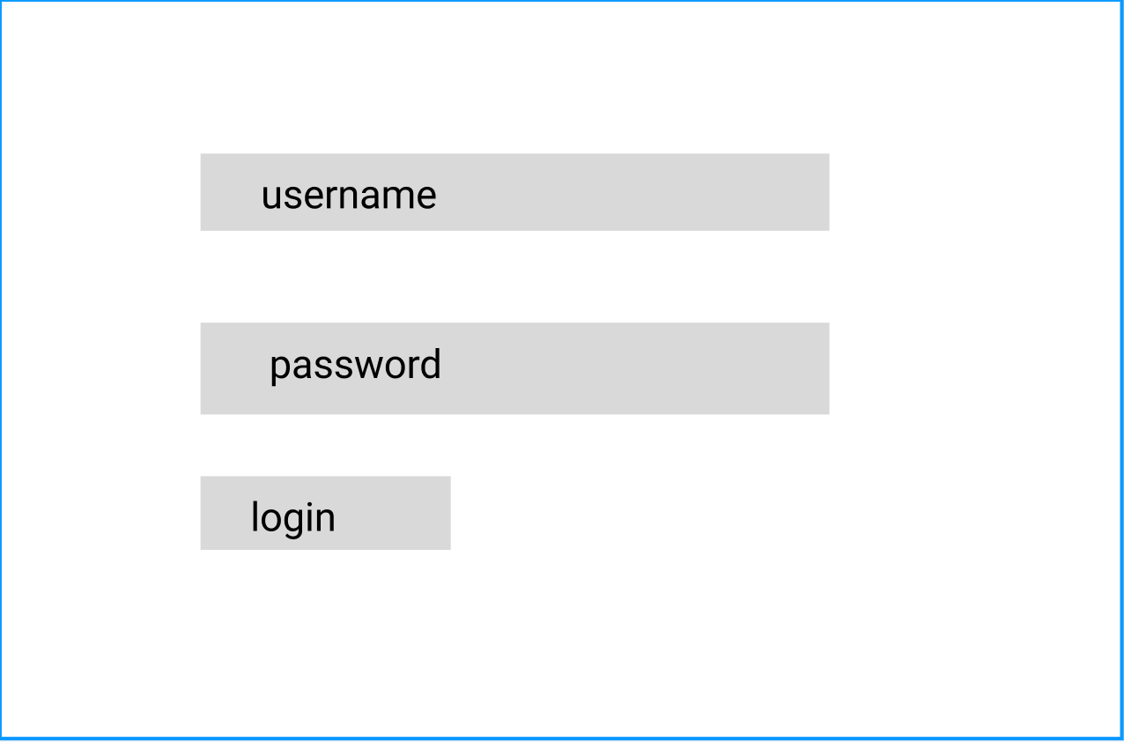

Import player data, **Persona – Football Scout story 1**

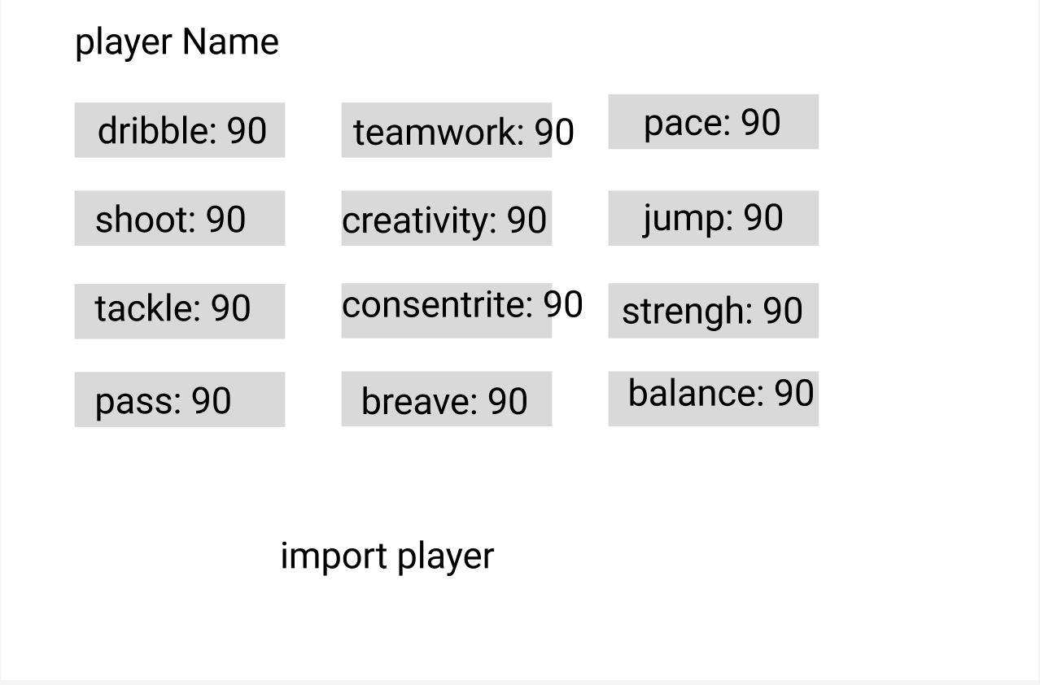

Filter player , **Persona – Football Manager story 1**

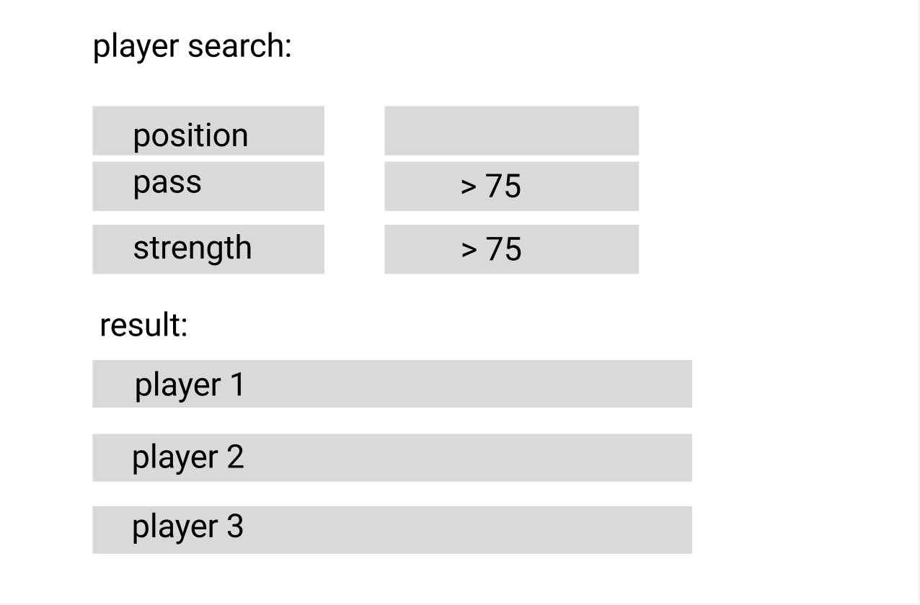

Compare player , **Persona – Football Manager story 2**

